Enghaveparken cloudburst park
Address: Enghavevej no. 50, 1674 København V
The buildup area and park originate from the 1920íes
Vesterbro area is served by two major projects:
- Enghaveparken, finished 2019
- Kalvebod cloudburst tunnel, finish 2027
In addition smaller green solutions are constructed, f.eks. at Carlsberg
The Vesterbro area, served by the two major projects: 240 ha
No. of households: 18,500
Total cloudburst volume: approx. 25,000 m3
Constructed 2016-2019
Cost: EUR 16 mill. (2020-prices), HOFOR 7,6 mill., Copenhagen Municip. Plus private funds 8,4 mill.
Biodiversity:
Mixture of green areas, trees bushes, cut grass, uncut grass and flowers.
Respect for national heritage
Support presence of bees and butterflies
Reuse of rain for secondary water:
Tappingplace at corner Ny Carlsbergvej and Enghavevej
Water for cleaning of streets
Water for watering af plants during dry period
Water for recreational puposes
Treament in double porous filter system, behind the white stage (Ejersedsgade)
Water for small channel on to of surrounding wall, the fountail place and open channel towards the lake
Citizens involvement
During design: public invitation to dinform, discuss and suggest
During construction: monthly newsletter
Additional info
Total water price 2025 is EUR 6 (water, wastewater, VAT)

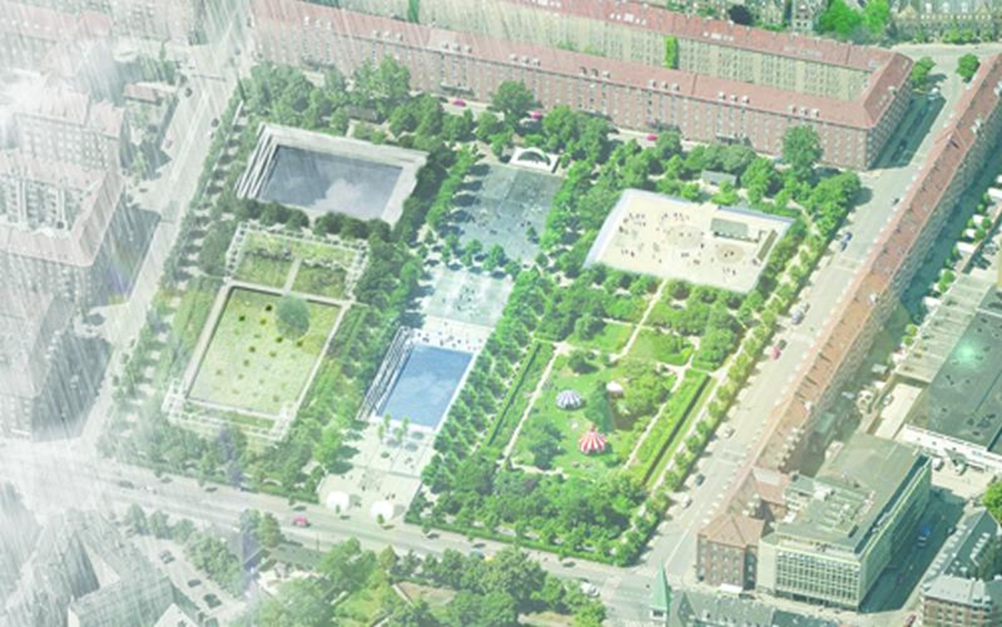

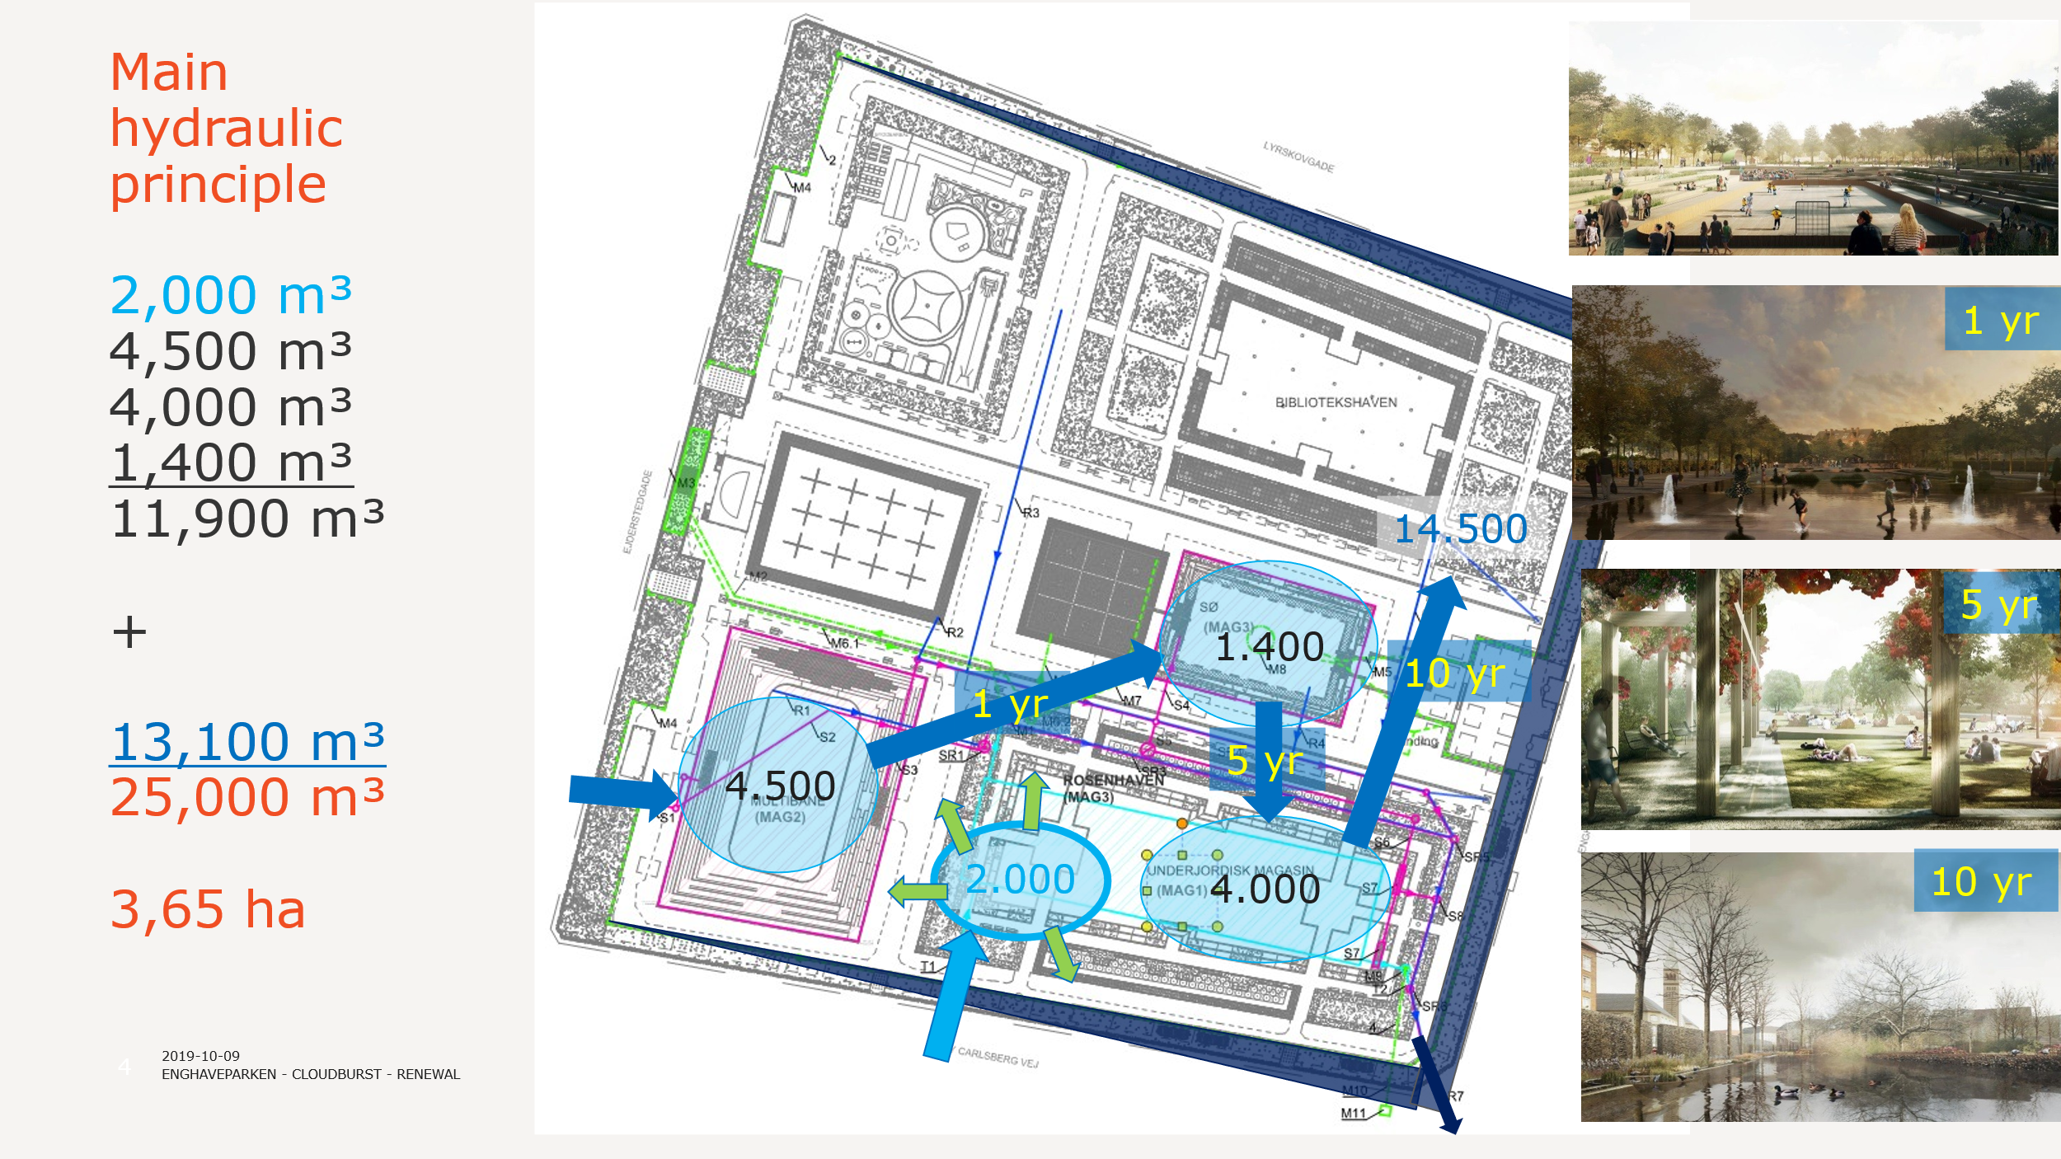
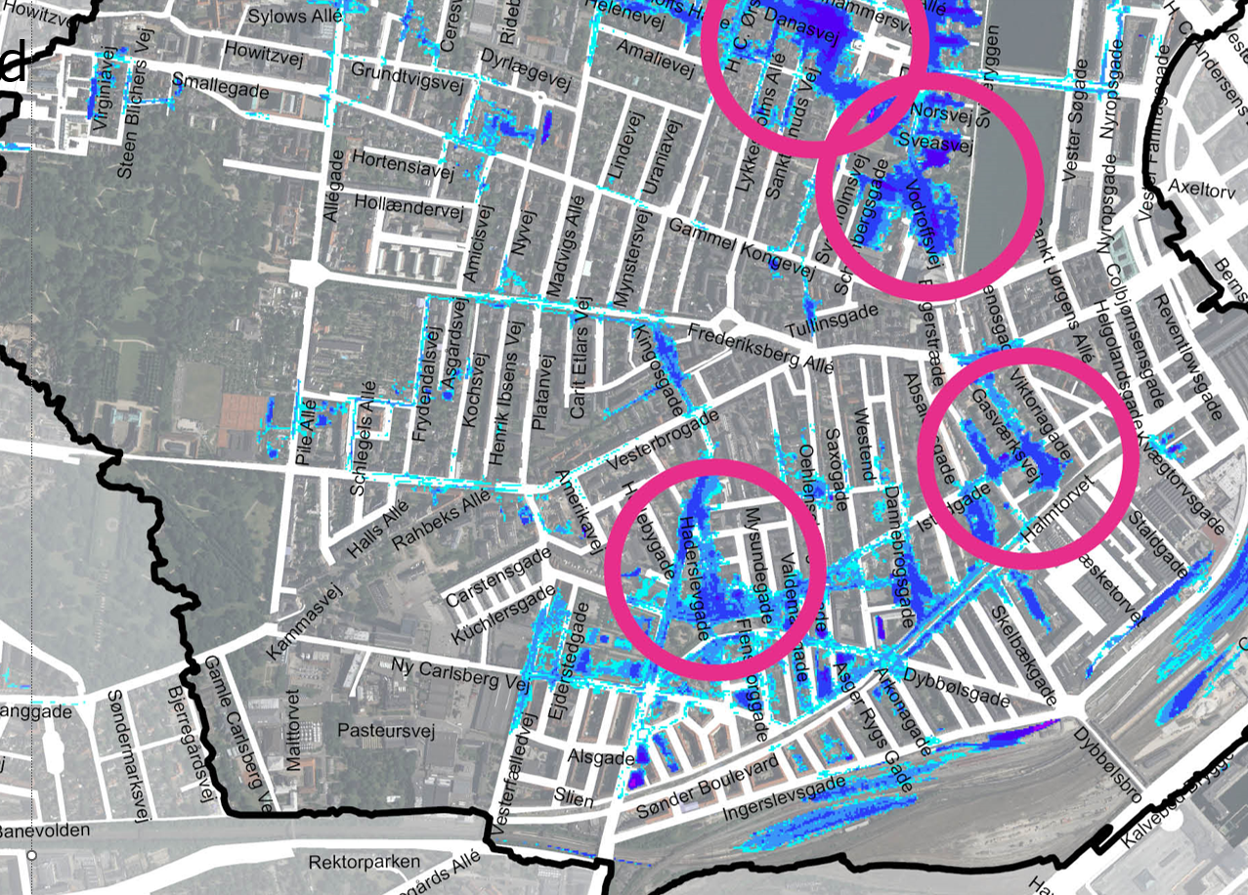
100-year flooding in the area

